# Torque calculations for motor selection:

It is important to check the torque of the servo motors, and estimate whether they are powerful enough to move the lenses, and hold the lenses in position (against their own weight) if the device is at a slight angle. For now, it is expected that the device will be operated with a slant of 10 degrees at most (otherwise the lenses would be unable to focus on the patient’s fundus).

Torque at 5V (from datasheet) for MG955 servo = 10kg-cm ~ 1Nm of torque

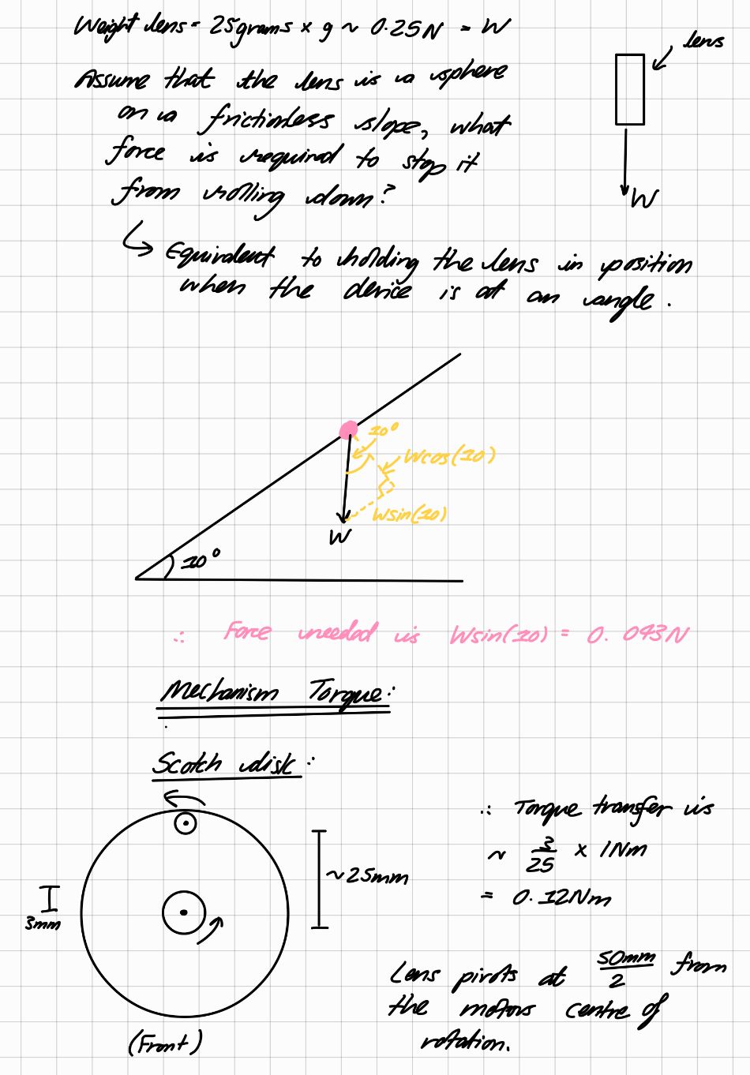Each lens weighs ~25g, estimated from their 50mm diameter and the density of glass

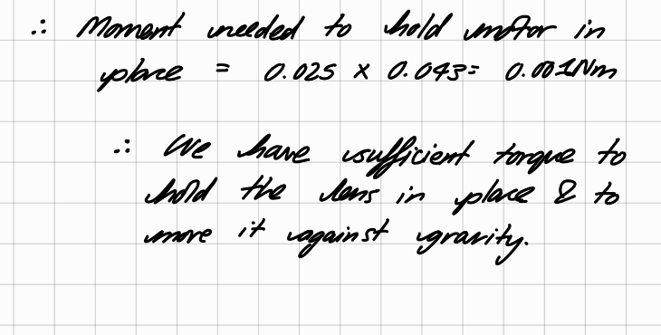

# Mass estimation:

Aluminium tube (12mm OD) ~ 0.26kg/metre

0.8m of tube used, therefore total mass of tubes = 208g

Lens are ~25g each, total mass = 50g

MG955 Servo motor = 70g each = 140g total

3D-printed parts (mass estimated from slicer, PLA used) = ~60g

|  |  |
| --- | --- |
| Part | Mass (g) |
| Aluminium tube | 208g |
| Lenses | 50g |
| MG955 Servo motor | 140g |
| 3D-printed parts | 60g |
| Total mass estimate for mechanism | 450g (2 d.p.) |

This is a lightweight yet robust assembly, which means that it fits our initial design requirements well. It is also able to withstand mild dust/dirt/vibrations.